NATIONAL UNIVERSITY OF SCIENCES AND TECHNLOGY

(DEPARTMENT OF MECHANICAL ENGINEERING)

FUNDAMENTALS OF PROGRAMMING

NAME: Syed Ali Naqi

SUBMITTED ON: 17-10-2023

CMS ID: 466889

TASK 1

#include <iostream>

using namespace std;

int main(){

int n=0;

int sum=0;

cout<<"enter any number you want to add"<<endl; cin>>n;

for( int i=1; i<=n; i++){

sum +=i;

}

cout<<"the sum of "<<n<<" first number is: "<<sum<<endl;

return 0;

}

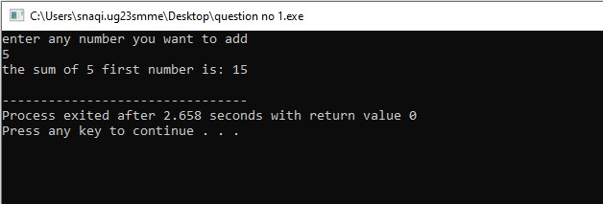

TASK 2

#include <iostream>

using namespace std;

int main(){

double number;

cout<<"enter the number";

cin>> number;

cout<<"table of"<<number<<endl;

for(int z=1 ;z<=10 ;z++){

cout<<number<<"x"<<z<<"="<<number\*z<<endl;

}

return 0;

}

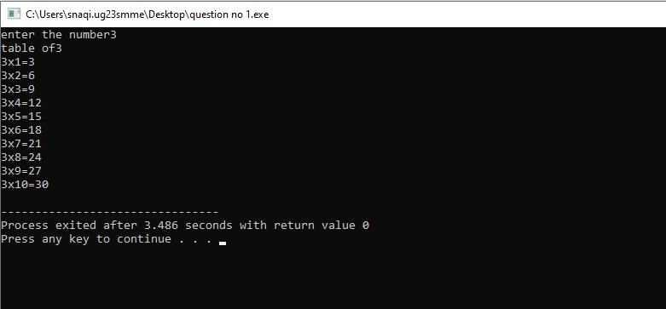

TASK 3

#include <iostream>

using namespace std;

int main(){

int factorial=1;

int zex;

cout<<"enter a number to find a factorial"<<endl;

cin>>zex;

for( int a=1; a<=zex; a++)

{

factorial \*=a;

}

cout<<factorial<<endl;

return 0;

}

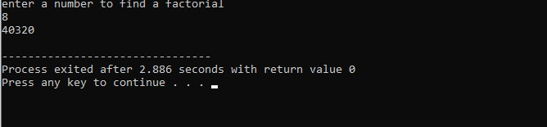

TASK 4

#include <iostream>

using namespace std;

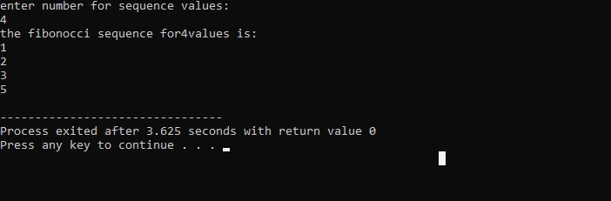

int main(){

int sequence, second=1, first =0;

int a;

cout<<"enter number for sequence values:"<<endl;

cin>>a;

cout<<"the fibonocci sequence for"<<a<<"values is: "<<endl;

for (int i=1; i<=a; i++)

if (i<=0){

sequence=i;

}

else {

sequence =first+second;

first =second;

second=sequence;

cout<<sequence<<endl;

}

return 0;

}